Design Document

Online College Portal

*Project 2023-2024*

**Team Members:**

Sandeep Mohanan

Amardeep Singh

**Faculty:**

Amardeep Singh

Document Control

|  |  |  |  |
| --- | --- | --- | --- |
| Revision History | | | |
| Date | Version | Author | Summary of Change |
| 25/05/2023 | 1.0 | Sandeep Mohanan | Initial version |
| 1/06/2023 | 1.1 | Amardeep Singh | Reviewed the draft |

|  |  |  |  |
| --- | --- | --- | --- |
| Approvals | | | |
|  | Name | Position | Date |
| Author | Sandeep Mohanan |  |  |
| Reviewed | Amardeep Singh |  |  |
| Approved | Amardeep Singh |  |  |

Contents

1. Introduction 6

1.1 Purpose and Scope 6

**Unexpected End of Formula**

1.3 Intended Audience 6

1.4 Product Scope 7

2. System Design 8

2.1 Background 8

2.2 Data Flow Diagram 8

2.3 Use Case Diagram 9

2.4 Sequence Diagram 9

3. Analysis 10

3.1 Requirement Analysis 10

3.2 Functional and Non-Functional Requirement 10

3.2.1 Functional Requirements 10

3.2.2 Non-Functional Requirements 11

4. Technology Used 12

4.1 HTML 12

4.2 JSP 12

4.3 CSS 13

4.4 SQL 13

5. Modules 14

5.1 Login module 14

5.2 Registration Module 14

5.3 Faculty Module 14

5.4 Student Module 14

5.5 Admin module 14

5.6 General Module 14

6. Conclusion 15

Appendix: 16

Acronyms and Abbreviations

|  |  |
| --- | --- |
| HTML | Hypertext Markup Language |
| SQL | Structured Query Language |
| JSP | Java Server Page |
|  |  |
|  |  |
|  |  |
|  |  |
|  |  |
|  |  |

# Introduction

## The impact of computers on our lives today is probably much more than we are actually known to. Getting good information and transforming it quickly into products than consumers want to buy is the essential key to staying in business and this all is done nowadays using Computers and Application Software. Online College Portal defines as an application (more likely web-based), that provides capabilities for multiple users with different permission levels to manage (all or a section of) content, data or information of a website project, or internet / application. The software helps Managers to plan and control the organizational operations and to respond to changing market conditions. It provides a regular flow of information for managerial decision-making and control.

## Purpose and Scope

The purpose of this document is to describe the specification and design for college portal. This document covers the functional and nonfunctional requirements, design, and modules of the online college portal. The scope is to design a college website which contains update information of the college that should improve efficiency of college record management.

## Objective

The main objective of this system is to reduce the consumption of time during maintaining the records of college. Separate divisions are providing to maintain the records of teachers, students, subjects and fees details. Our System also provides an easy way not only to automate all functionalities of a college, but also to provide full functional reports to top management of college with the finest of details about any aspect of college. In other words, our OCP has, following objectives: Simple database is maintained. Easy operation for the operator of the system. User interfaces are user friendly and attractive; it takes very less time for the operator to use the system

## Intended Audience

This document is intended for the following audience:

* New/Existing Student
* Faculties
* Registrar or Administrator

## Product Scope

This type of software is suitable for all colleges. Separate division is provided to maintain Students, Teachers record, Events and Discussion etc.

• Public: OCP, since an open project needs public communications.

• Approachable: Needs to be accessible to potential new community members, ideally without making them learn something new.

• Asynchronous: with people all around the world, the primary communications need to be not-real time

• Multiple participant: Multiple User Participation

• Archived: Store People Opinion and feedback

• Searchable: Easy Search

• Filterable: no-one can read every project communication; there needs to be a way of splitting by topic

• Accessible: needs to be accessible to new and future disabled community members

## 

# System Design

This section will cover the data flow diagram, detailed flow graph, requirement analysis, and the design process of the front end and back end design of the OCP system.

## Background

[JSP](https://www.geeksforgeeks.org/introduction-to-jsp/) architecture gives a high-level view of the working of JSP. JSP architecture is a 3 tier architecture. It has a Client, Web Server, and Database. The client is the web browser or application on the user side. Web Server uses a JSP Engine i.e; a container that processes JSP. For example, Apache Tomcat has a built-in JSP Engine. JSP Engine intercepts the request for JSP and provides the runtime environment for the understanding and processing of JSP files. It reads, parses, builds Java Servlet, Compiles and Executes Java code, and returns the HTML page to the client. The webserver has access to the Database. The following diagram shows the architecture of JSP.

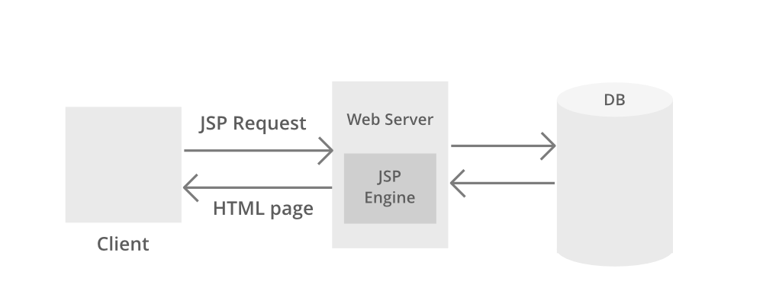

This specification and design document covers:

* New Student registration and current student’s academic activities.
* Facilities supported tasks such as assessment loading, Publish marking and group message posting.
* Admin support activities such as generate the student’s certificate, create student profile and approve new registration.

## Data Flow Diagram

A Data Flow Diagram (DFD) is a graphical representation of the flow of “Online College Portal”. A data Flow diagram can also be used for the visualization of Data Processing shows the interaction between the system and outside entities. This context-level DFD is then “exploded” to show more detail of the system being modelled. A DFD represents flow of data through a system. Data flow diagrams are commonly used during problem analysis. It views a system as function that transforms the given input into required output. Movement of data through the different transformations or processes in the system are shown in Data Flow Diagram.

## Use Case Diagram

The use case diagram depicts the essential functionality and actors of the application namely admin and student.

## Sequence Diagram

The sequence diagram depicts the entities that interact with each other. The diagram shows in detail the sequence of events occurring during the implementation of the proposed System.

# Analysis

## Requirement Analysis

The basic requirements for the design of the OCP are:

• Every user should have unique identity

• Login facility.

• User can update his/her personal information and can view the notice, results, placement and exam section updates etc. Faculty/staff, discussion and exam sections can update any of the information.

## Functional and Non-Functional Requirement

Functional requirements that the end user specifically demands are basic facilities that the system should offer. All these functionalities need to be necessarily incorporated into the system as a part of the contract. These are represented or stated in the form of input to be given to the system, the operation performed, and the output expected. They are basically the requirements stated by the user which one can see directly in the final product, unlike the non-functional requirements. Non-functional requirements: These are basically the quality constraints that the system must satisfy according to the project contract. The priority or extent to which these factors are implemented varies from one project to other. They are also called non-behavioural requirements.  
They basically deal with issues like:

* Portability
* Security
* Maintainability
* Reliability
* Scalability
* Performance
* Reusability
* Flexibility

### Functional Requirements

Online College Portal system aims to improve the efficiency of college information management, and the main function is managing and maintaining information. The administrator and students are two major functional requirements in the system. The Administrator will be given more powers (enable/disable/ update) than other users. It will be ensured that the information entered is of the correct format. For example name cannot contain numbers. In case if incorrect form of information is added, the users will be asked to fill the information again. Students use the system to query

|  |  |  |  |  |
| --- | --- | --- | --- | --- |
| Use table | Use table | Use table | Use table | Use table |
| Use table | Use table | Use table | Y | Use table |
| Use table | Use table |  | Y | Use table |

### Non-Functional Requirements

Performance Requirements: The proposed system that we are going to develop will be used as the chief performance system for helping the organization in managing the whole database of the student studying in the organization and having message notifications. Therefore, it is expected that the database would perform functionally all the requirements that are specified. • Safety Requirements: The database may get crashed at any certain time due to virus or operating system failure. Therefore, it is required to take the database backup. • Security Requirements: We are going to develop a secured database. There are various categories of people namely Administrator, Student who will be viewing either all or some specific information. Depending upon the category of user the access rights are decided. It means if the user is an administrator then he can be able to modify the data, append etc. All other users only have the rights to retrieve the information from database. • Database Management System (DBMS) is a collection of programs that enables users to create and maintain a database. DBMS is a general – purpose software system that facilitates the process of defining, constructing, manipulating, and sharing database among various users and applications. Defining a database involves the specifying the data types, structures, and constraints of the data to be stored in the database. The database definition or descriptive information is also stored in the database in the form of dictionary; it is called Meta data constructing the database is the process of storing the data on the storage medium that is controlled by DBMS

|  |  |  |  |  |
| --- | --- | --- | --- | --- |
| Use table | Use table | Use table | Use table | Use table |
| Use table | Use table | Use table | Y | Use table |
| Use table | Use table |  | Y | Use table |

# Technology Used

Online College Portal (OCP) provides a simple interface for maintenance of student–faculty information. It can be used by educational institutes or colleges to maintain the records of students easily. The creation and management of accurate, update information regarding a students’ academic career is critically important in the university as well as colleges. Student information system deals with all kind of student details, academic related reports, college details, course details, curriculum, batch details, placement details and other resource related details too. It tracks all the details of a student from the day one to the end of the course which can be used for all reporting, tracking of attendance, progress in the course, completed semesters, upcoming semester year curriculum details, exam details, project or any other assignment details, final exam result and all these will be available through a secure, online interface embedded in the college’s site. It will also have faculty details, batch execution details, students’ details in all aspects, the various academic notifications to the staff and students updated by the college administration. It also facilitate us explore all the activities taking place in the college, different reports and queries are generated based on vast options related to students, batch, course, faculty, exams, semesters, certification and even for the entire college.

## HTML

HTML is a hypertext mark-up language which is in reality a backbone of any website. Every website can’t be structured without the knowledge of html. If we make our web page only with the help of html, than we can’t add many of the effective features in a web page, for making a web page more effective we use various platforms such as CSS. So here we are using this language to make our web pages more effective as well as efficient. And to make our web pages dynamic we are using Java script.

## JSP

JSP stands for Java Server Pages. It is a server-side technology. It is used for creating web applications. It is used to create dynamic web content. JSP tags are used to insert JAVA code into HTML pages. It is an advanced version of Servlet Technology. It is a Web-based technology that helps us to create dynamic and platform-independent web pages. In this, Java code can be inserted in HTML/ XML pages or both. JSP is first converted into a servlet by JSP container before processing the client’s request. **JSP** processingis illustrated below.

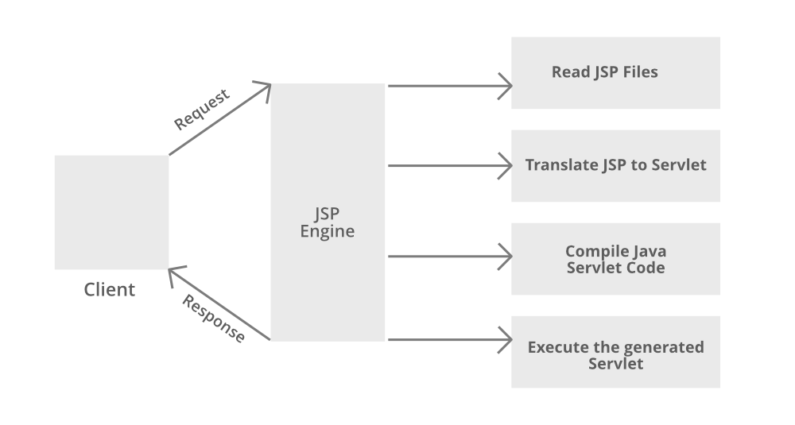

## CSS

CSS stands for "Cascading Style Sheet." Cascading style sheets are used to format the layout of Web pages. They can be used to define text styles, table sizes, and other aspects of Web pages that previously could only be defined in a page’s HTML. The basic purpose of CSS is to separate the content of a web document (written in any markup language) from its presentation (that is written using Cascading Style Sheets). There are lots of benefits that one can extract through CSS like improved content accessibility, better flexibility and moreover, CSS gives a level of control over various presentation characteristics of the document. It also helps in reducing the complexity and helps in saving overall presentation time. CSS gives the option of selecting various style schemes and rules according to the requirements and it also allows the same HTML document to be presented in more than one varying style

## SQL

SQL stands for Structured Query Language. SQL lets us access and manipulate databases. SQL is an ANSI (American National Standards Institute) standard. SQL can execute queries against a database ,retrieve data from a database, insert records in a database, update records in a database, delete records from a database, create new databases , create new tables in a database , create stored procedures in a database, create views in a database, set permissions on tables.

# Modules

This project is developed as multiple modules.

## Login module

Login module will cover login process of application. Multiple groups are created to support these operations. This module will cover student, Faculty and admin login.

## Registration Module

The Registration module is covering the new student and Faculty registration .The admin will verify the details and approve or disapprove the registration.

## Faculty Module

The Faculty module will cover the assessment download, marking and feedback, resource loading and general message posting.

## Student Module

The Student module will cover education material, assignment submissions and semester Calendar.

## Admin Module

The Admin Module will cover managing user, administration of different modules, daily management and report generation for management.

## General Module

The General Module will cover management of public relationship via emails and posts, car parking and advertisement.

# Conclusion

This paper assists in automating the existing manual system. This is a paperless work. It can be monitored and controlled remotely. It reduces the man power required and provides accurate information. Malpractice can be reduced. All years together gathered information can be saved and can be accessed at any time. Therefore the data stored in the repository helps in taking decision by management. So it is better to have a Web Based system. All the stakeholders, faculty and management can get the required information without delay. This system is essential in the colleges and universities.

# Appendix:

# 